Day 3 Activity 1 4 main characters in the story of 小白鶴笑了

Task 1: Find the components of “鸟”and“隹” in the characters on the right column.
Task 2: Place pinyin and tone for each word on the right column.
Task 3: Match the words with the photos.

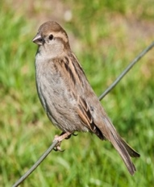 | 孔雀  pinyin+tone ___________________
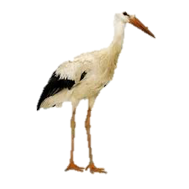 | 麻雀  pinyin+tone ___________________
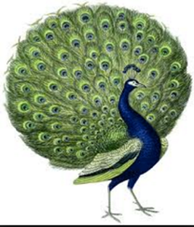 | 小鸭  pinyin+tone ___________________
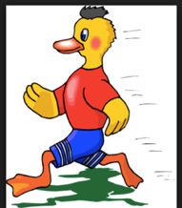 | 小白鹤  pinyin+tone ___________________

